Atlantic Coast Trail, Flexible Riding and One Week Riding Courses
Jour 1 à 7

Equestrian Guest House – 55, Route de Baleste ( in Mimizan)

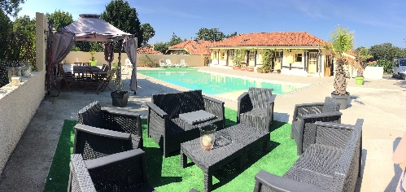 | Equestrian Guest House from the 17th century “ Chambres d’Hôte “ with a huge private pool, is situated at less than 10 minutes by car from Mimizan beach and 1 minute by foot from the stable.  Renovated with love, these 3 stars place provides comfortable bedrooms for 2 to 4 people, private bathroom with Italian shower or bath, floor heating an wireless access.  FREE WIRELESS ACCESS.  .
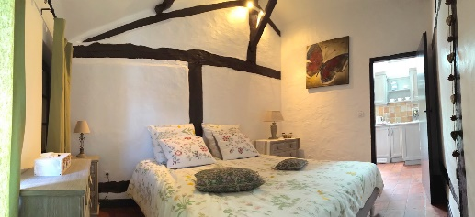 | 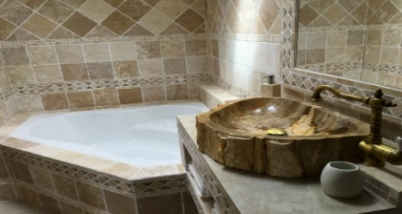
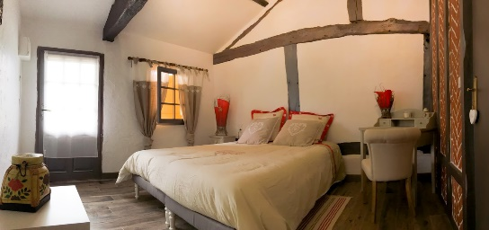 | 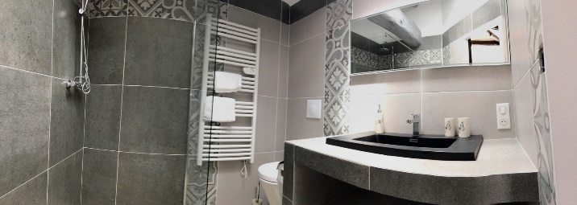
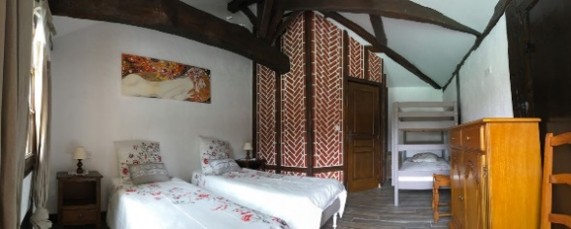  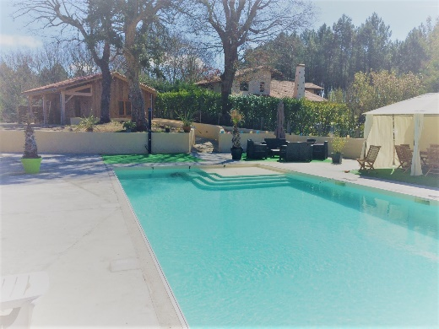 | 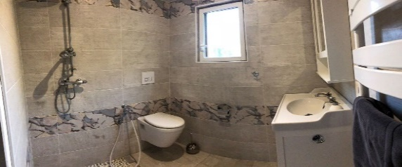  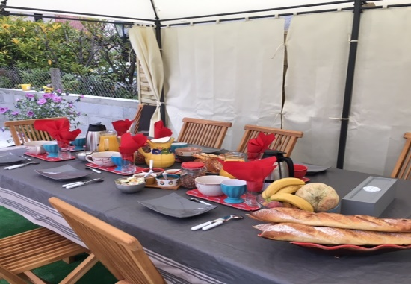
COMBO PAYS BASQUE MOUNTAIN and ATLANTIC BEACH OCEAN 2019

Jour 1
Amestoia – Guest House – St Etienne de Baigorry
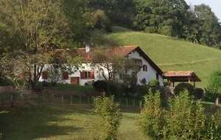 | This 15th-century house set in the heart of the Basque country, 10 km from Saint-Jean-Pied-de-Port and 50 km from Biarritz and Bayonne, and 12 km from the Spanish border  This 3 stars Guest House offers views of the surrounding hillsides and vineyards !  Each room is individually decorated with private bathroom.  FREE WIRELESS ACCESS. .
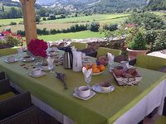 | 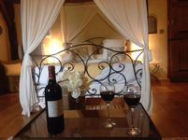
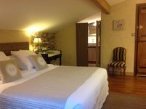 | 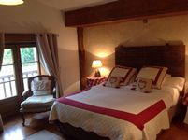
Jour 2
Night Mountain Guest House " Gîte Espila ".

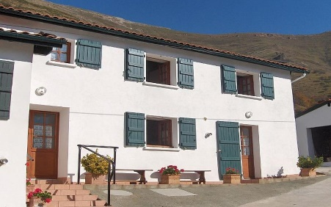 | Mountain Guest House “ Gite de Montagne “ At 800 m height, on the summit of the Basque Pyrenees mountains ,  Situated at 17 km distance from the pilgrim city « St Jean Pied de Port », and 2 km from the Spanish border this Guest House offer to relax in a nice farm environment,; quiet place with amazing views on the mountains and sunset.
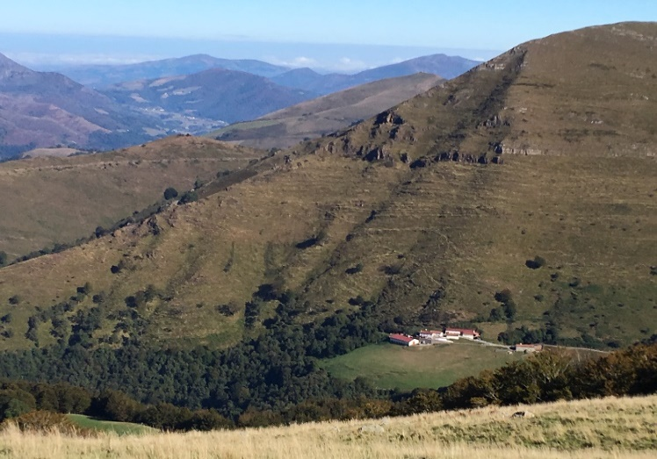 | This family propriety offer a surface of 148 m², with bathroom and dining room on the ground floor 3 bedrooms from 1 to 3 people at the first floor and 2 bathrooms to share An additional guest house at 300m distance with 2 bedrooms from 1 to 3 people and 1 bathroom to share.  FREE WIRELESS ACCESS. possible according to the weather conditions.
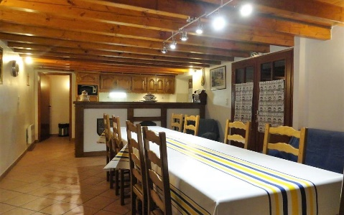 | 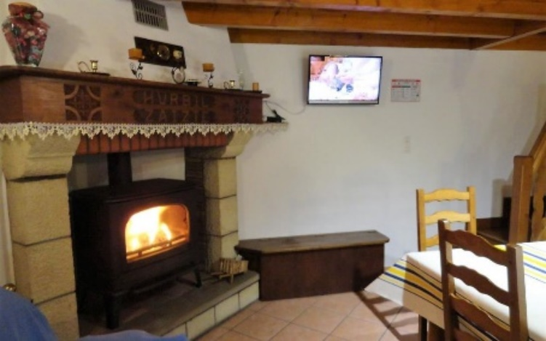
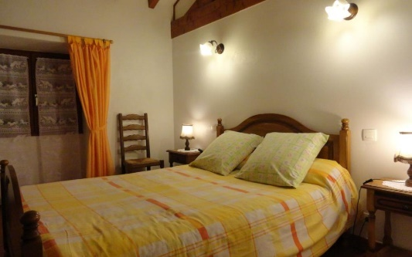 | 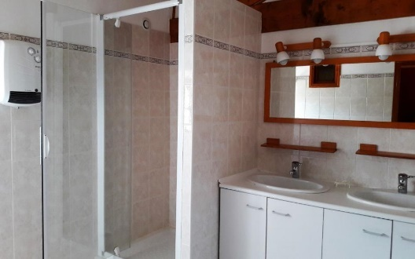
Jour 3 et 4

Hotel Erreguina – Banca

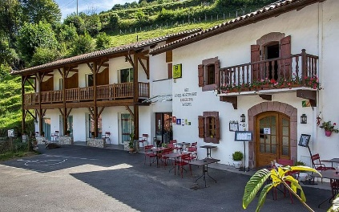 | Charming 2 stars Family Hotel, renovated with love.  Situated in the centre of the village of Banca, at 5 km from the Spanish border, this hotel provides nice bedrooms with flat screen television and private bathrooms with Italian shower. Some of the rooms offer also balconies. FREE WIRELESS ACCESS.
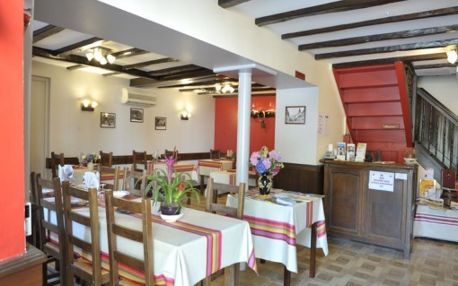 | 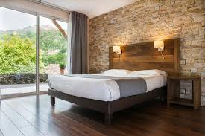
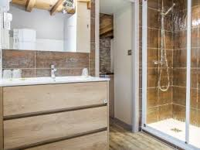 | 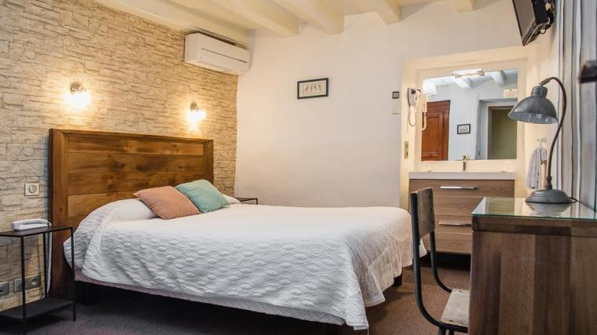
Jour 5 à 7

Equestrian Guest House – 55, Route de Baleste ( in Mimizan)

Equestrian Guest House from the 17th century “ Chambres d’Hôte “ with a huge private pool, is situated at less than 10 minutes by car from Mimizan beach and 1 minute by foot from the stable.
Renovated with love, these 3 stars place provides comfortable bedrooms for 2 to 4 people, private bathroom with Italian shower or bath, floor heating FREE WIRELESS ACCESS.

More photos on the Atlantic Coast trail program

Raid in Perigord and on Atlantic Coast
Jour 1 à 4

L’Hameau de Peyrié – Château de Bonaguil

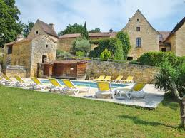 | Located 700m from the famous castle Bonaguil , the Peyrie is a small village built on an area of 14 hectares of meadows and undulating wood, away from roads and other dwellings, a privileged environment.  Le Hameau du Peyrie, which dates back to the sixteenth century, is built of golden stone of the country, which gives it that warm character throughout the year.
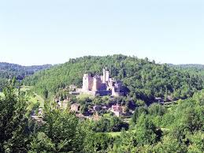 | Fully restored, it is now composed of 4 charming cottages , various outbuildings including a beautiful bread oven Each cottage is fully furnished and features an outdoor terrace with garden furniture and barbecue.  Its isolated location and its green setting, where oak woods, chestnut and pine trees mingle, form a set for relaxation and well-being. FREE WIRELESS ACCESS.
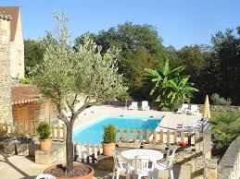 | 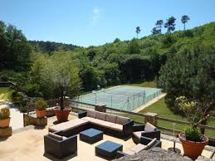
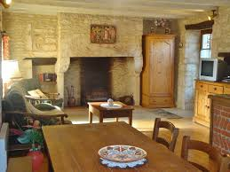 | 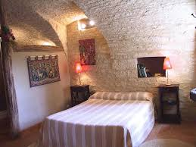
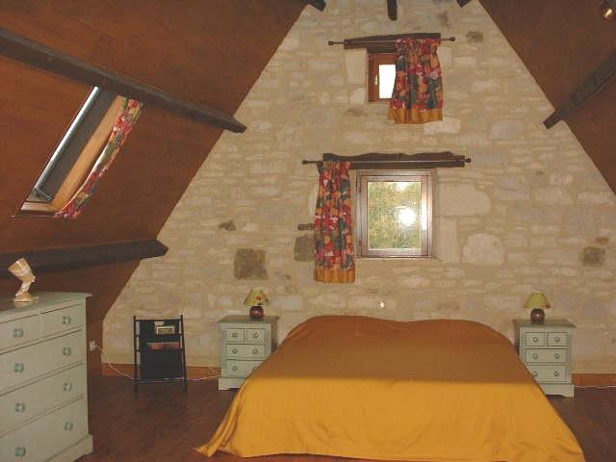  Jour 5 à 7 | 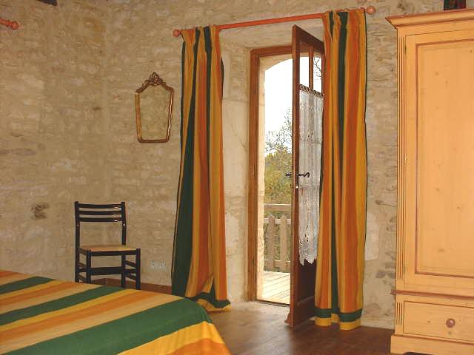
Equestrian Guest House – 55, Route de Baleste ( in Mimizan)

Equestrian Guest House from the 17th century with a huge private pool, providing 5 different rooms and situated at 10 minutes from the beach . Renovated with love, this 3 stars place provides comfortable rooms, each room with private bathroom, Italian shower and twin or 160cm double beds, floor heating an wireless access.
FREE WIRELESS ACCESS.

More photos on the Atlantic Coast trail program

